Questions 1:

1. 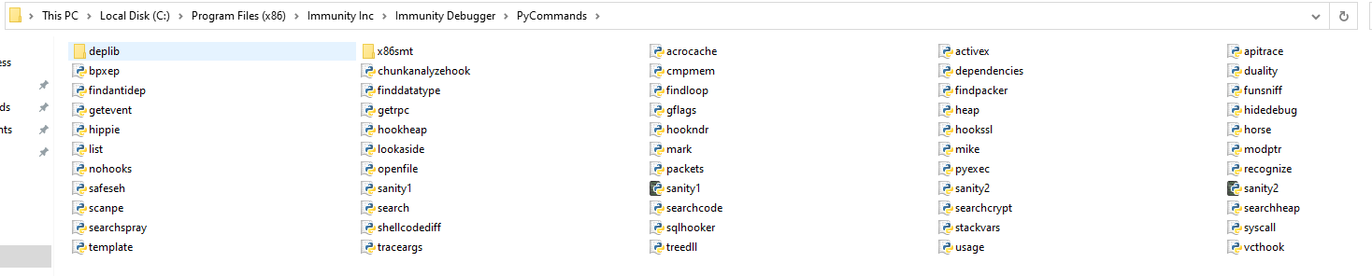
2. .py (python) files
3. 
4. Only the owner can save to the folder, so we have the permissions to be able to save to the folder

Problem 2:

Screenshots:

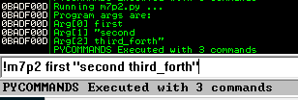

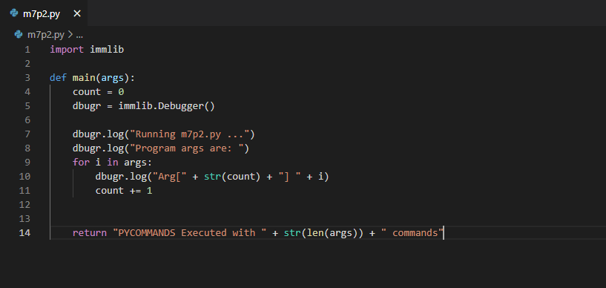

Questions 2:

1. “return” function
2. <name of debugger object>.log()
3. No, you cannot

Problem 3:

1. 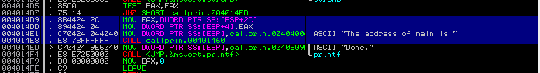



1. 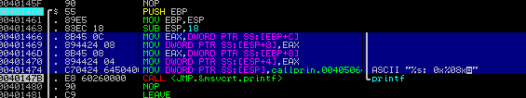



Problem 4:

Questions 4:

1. A list of tuples
2. It allows the programmer to override whatever address is given, so B337F00D is the address of the message displayed in the address column to the left
3. string[0] : Address of the command

string[1] : The command itself

string[2] : any ASCII comments

1. find string code:

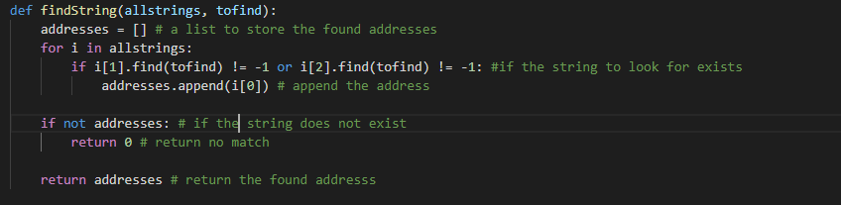

1. find function code: 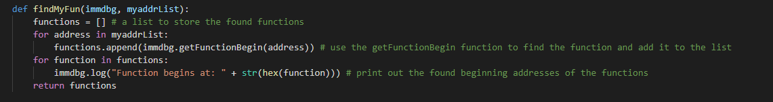
2. set breakpoint code: 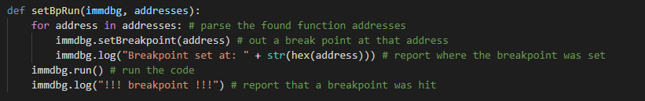
3. modified main code (other functions found above): 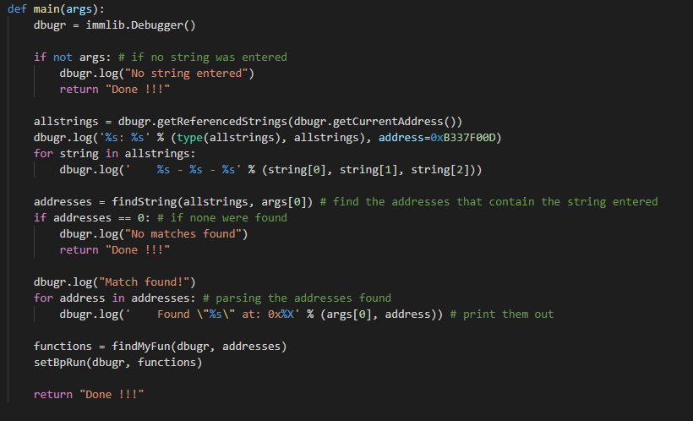

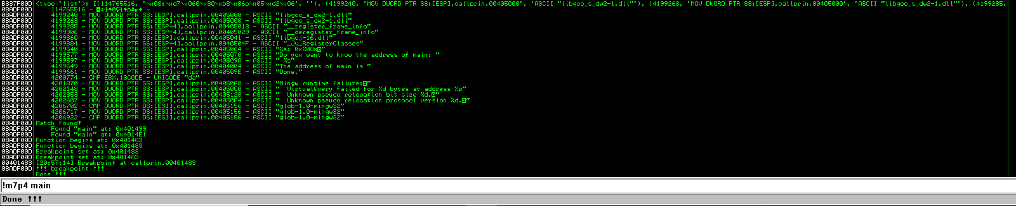Output of final code:

Problem 5:

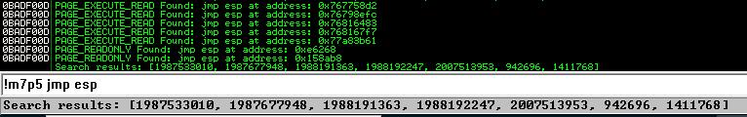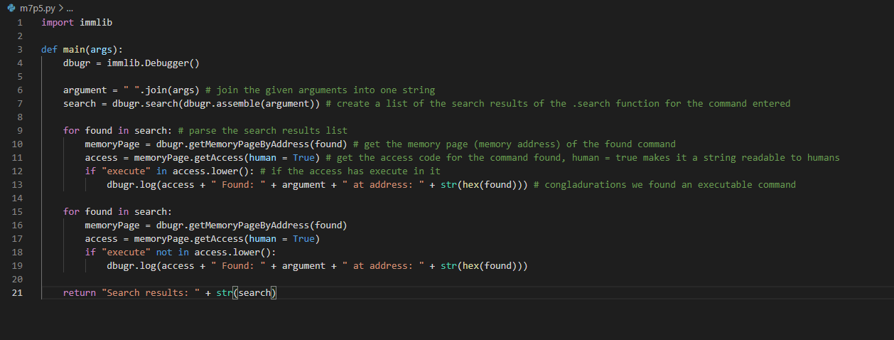Screenshots:

Questions 5:

1. A list of addresses of places where the command was found



1. Gets the memory page of the passed address. It is then used later to determine the access value
2. It gets the access value of the memory page, which determines the permissions of the command, the human=true part makes the return in the form of a readable string instead of a number code.

